**SSH:**

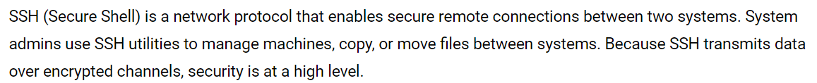

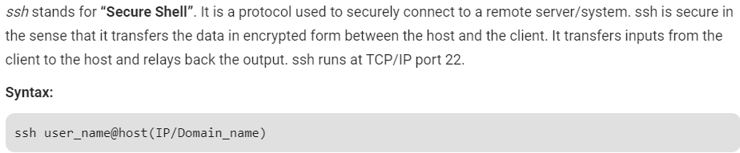

**How to access remote server:**

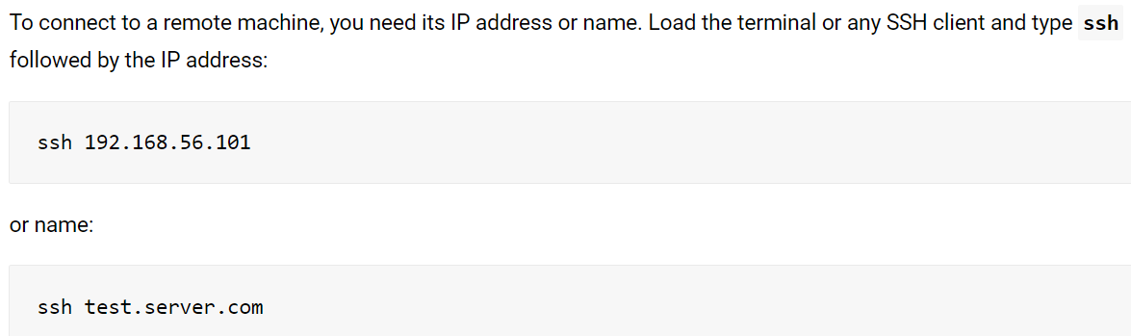

* We can also specify username as below. If we don’t specify, it will by default takes the current user of current machine from which we are using SSH.

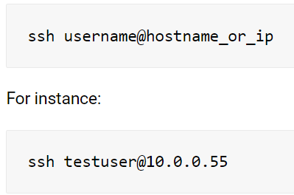

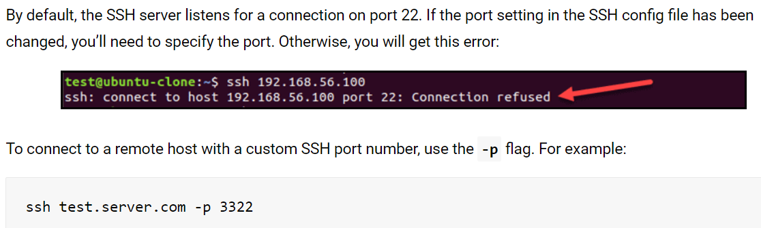

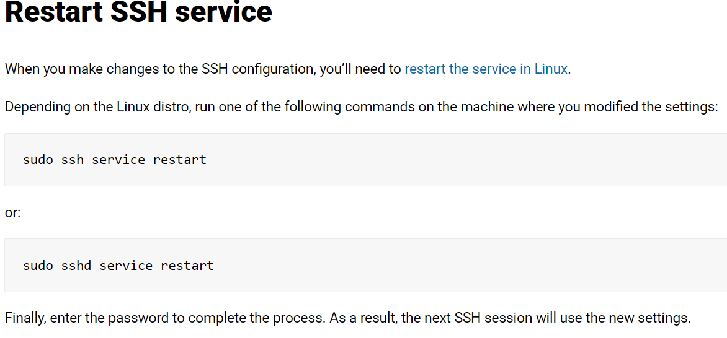

**SSH config file:**

* We can set ssh configuration on system level at **“/etc/ssh/ssh_config”** or on user level at **“~/.ssh/config”**

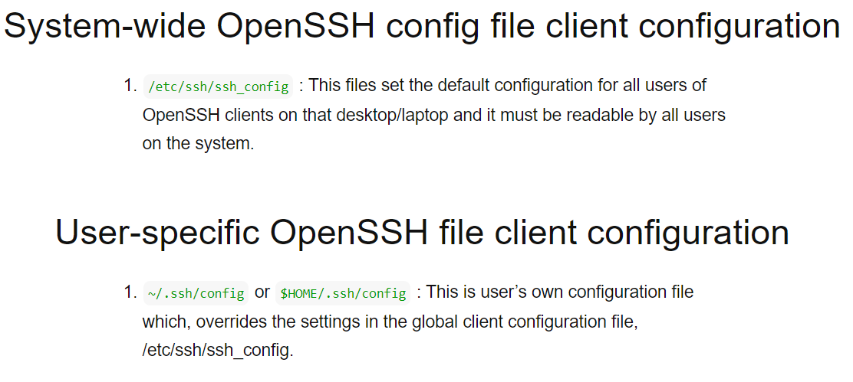

**Commonly used options:**

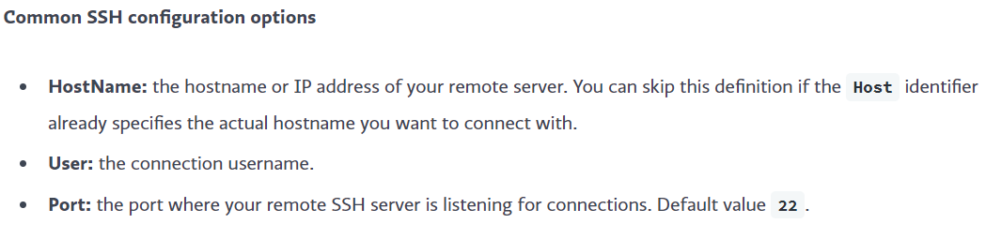

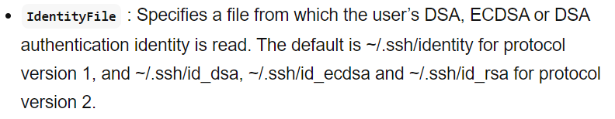

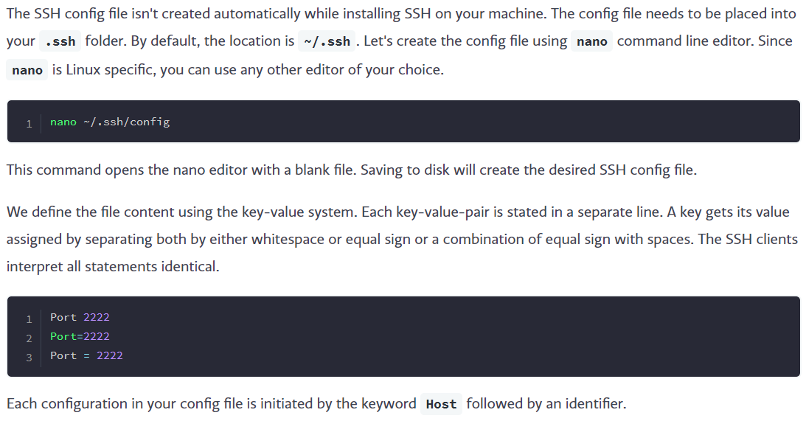

* Now, we can add the hosts in config file as below.

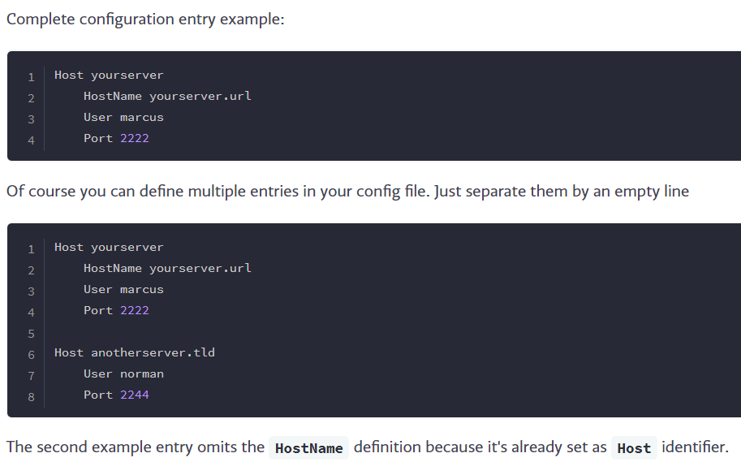

* After this, we can just connect to the machine by giving “Host” name instead of giving the IP or hostname every time as below.

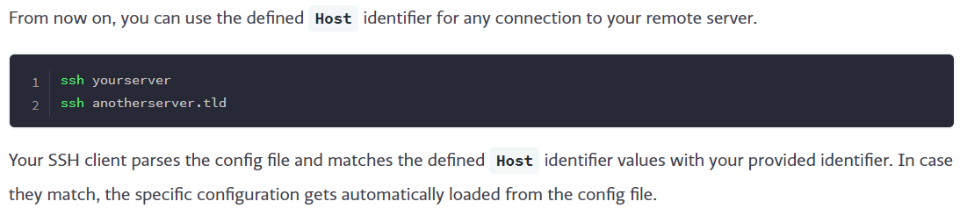

* We can also use “IdentityFile” options to give the path of key for the authentication.

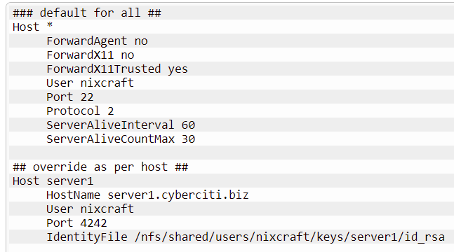

**Known_hosts file:**

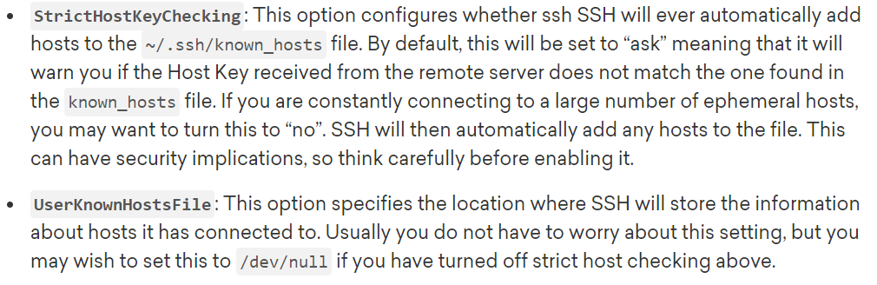

* We can also use the above options to disable storing the hostnames into known_Hosts file and also, we can specify any different file to store the host details.
* We can even pass this in command as below.

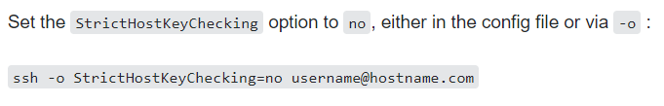

**Wildcard entries:**

* We can also do entries in config file as below.

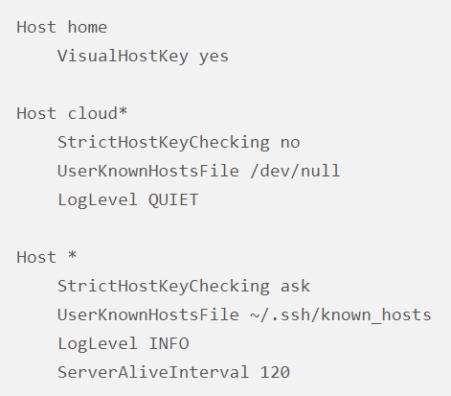

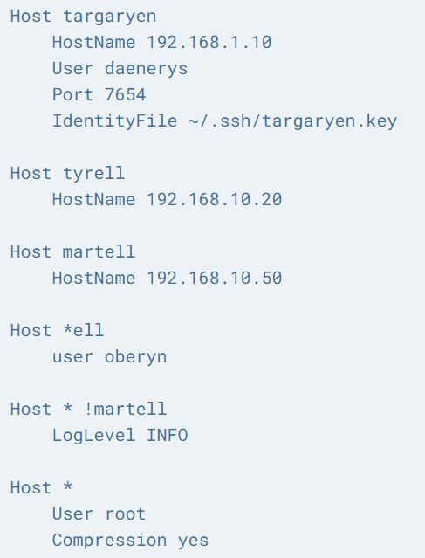

**SSH Tunnelling/Port Forwarding:**

* SSH tunneling or SSH port forwarding is a method of creating an encrypted SSH connection between a client and a server machine through which services ports can be relayed.
* SSH forwarding is useful for transporting network data of services that uses an unencrypted protocol, such as VNC or FTP , accessing geo-restricted content or bypassing intermediate firewalls. Basically, you can forward any TCP port and tunnel the traffic over a secure SSH connection.

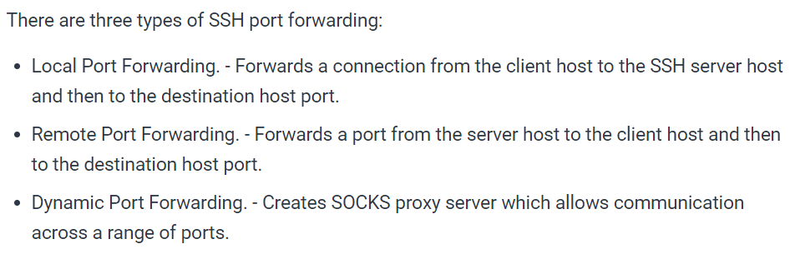

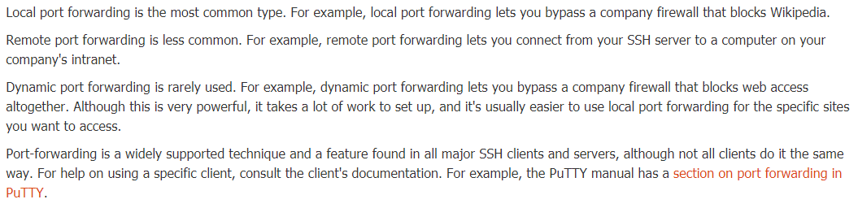

**Local port forwarding:**

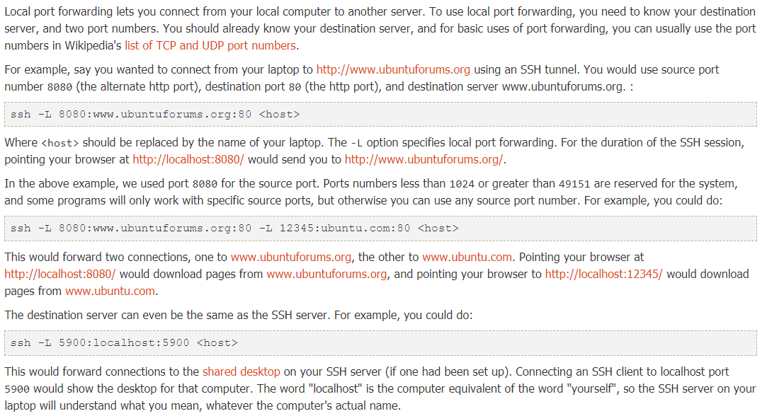

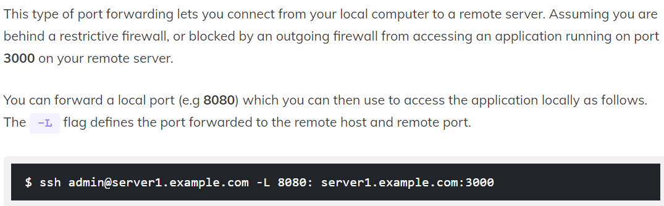

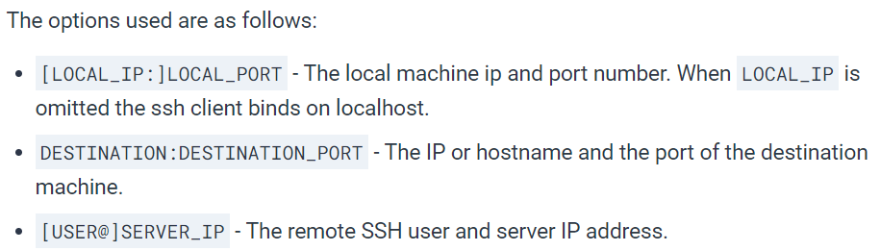

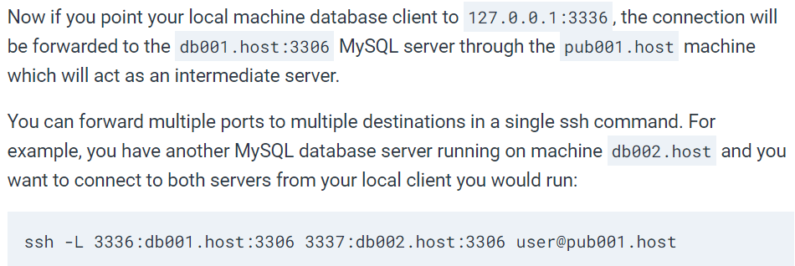

**sshpass command:**

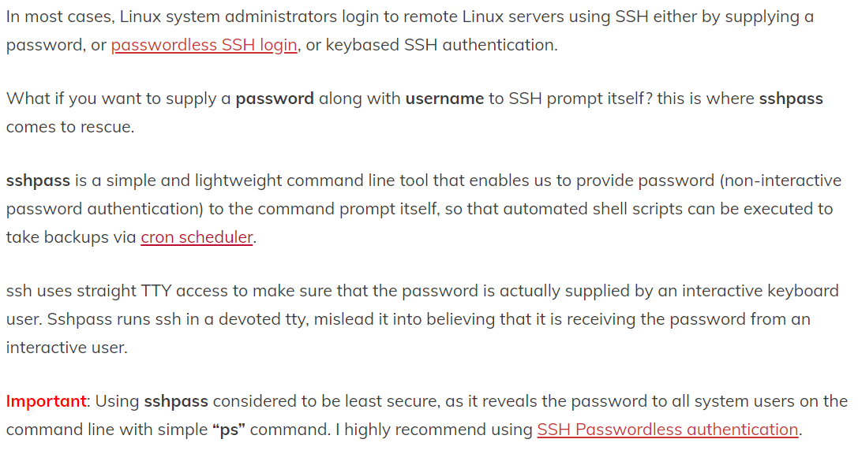

**Installation:**

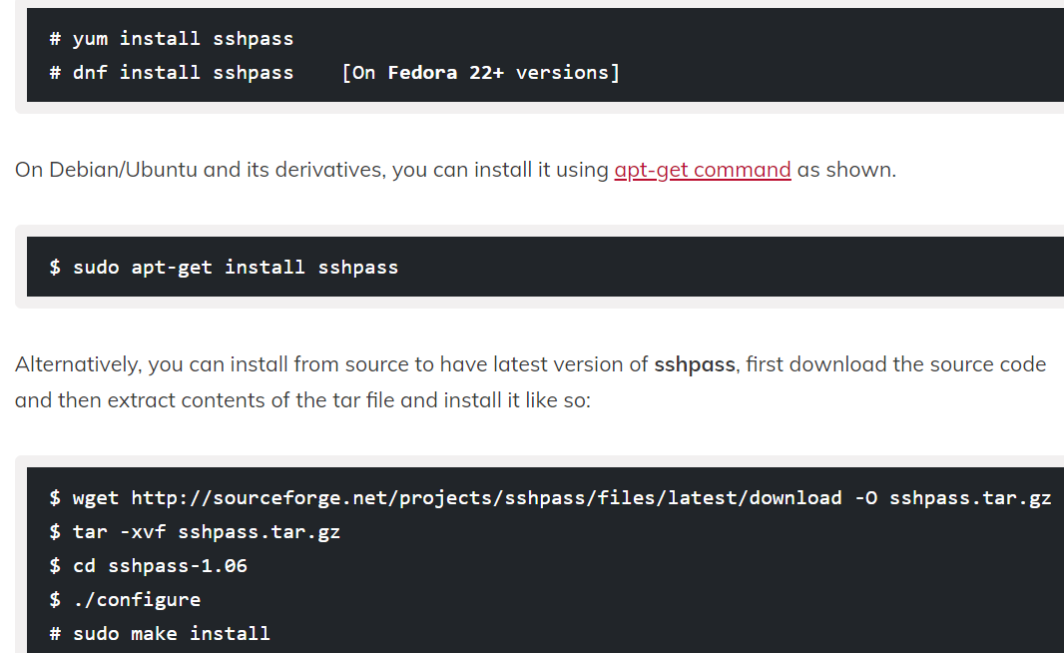

**Options:**

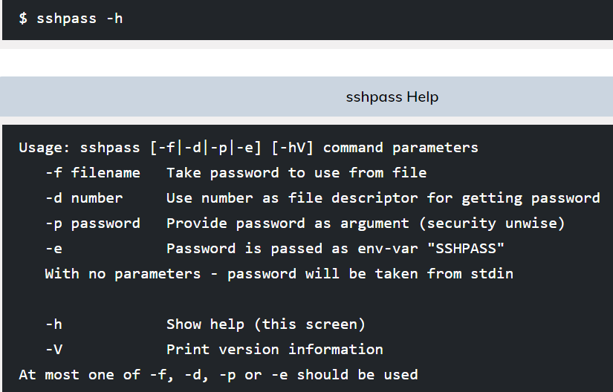

**Examples:**

* We can pass the password in command line as below. Also, we can execute any command if we want. We executed “df -h” in below example.

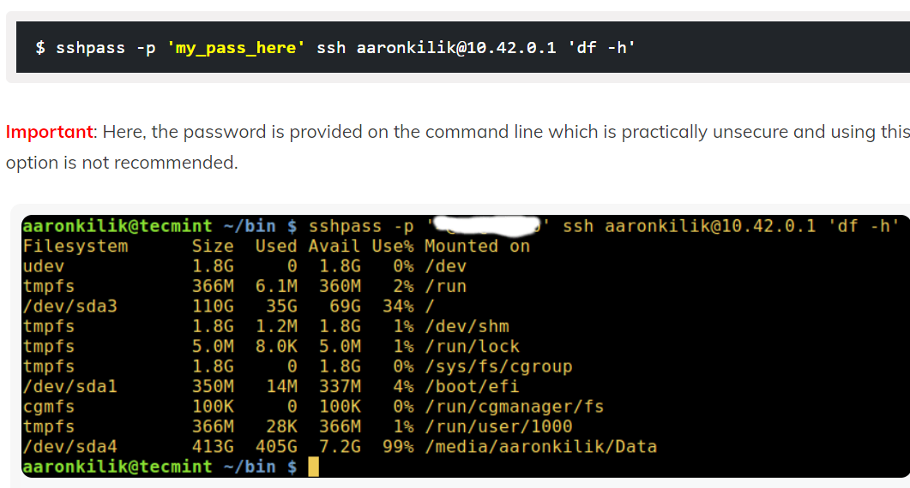

* We can also pass the password in environment variable as below. Below is the example to pass the variable temporarily. We can also add it permanently in bash_profile.

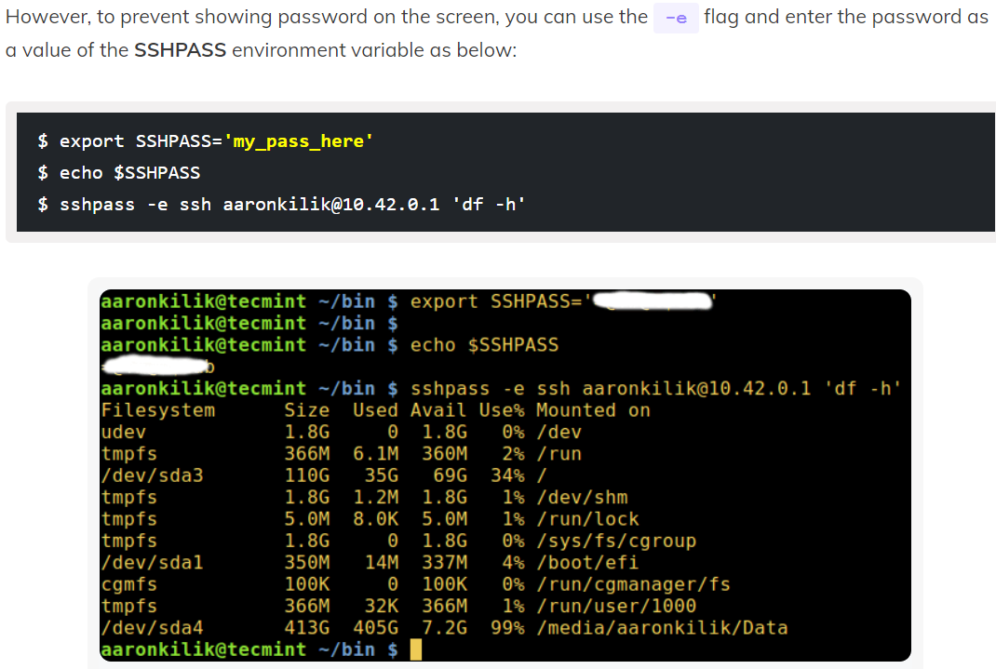

* We can even provide the password in file as below example.

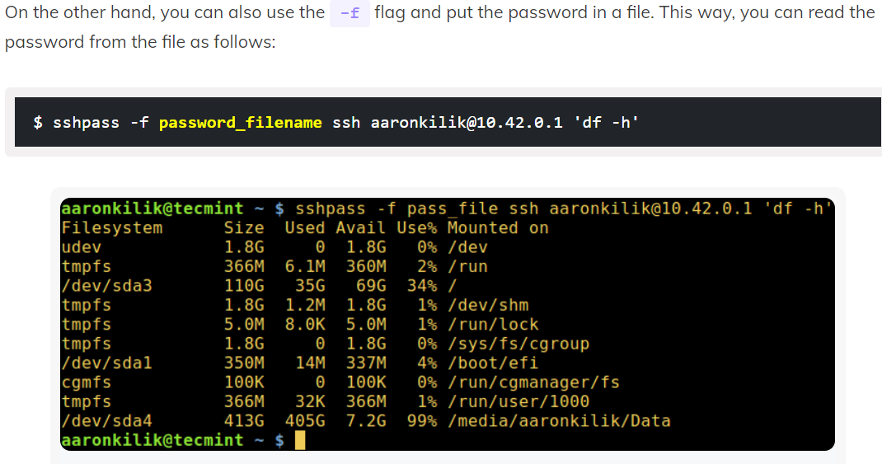

Below is the example to use scp command in sshpass.

* **sshpass -p 9xbUyCNkatYA7yvf scp 19479.zip 10.8.6.6:/tmp**

and the command to use rsync below.

* **sshpass -p "password" rsync root@1.2.3.4:/abc /def**